AMOS KIPNGENO
C025-01-0958/2021

CLIMATE CHANGE AND ENVIRONMENTAL CRISIS IN AFRICA: A PHOTOGRAPHIC ESSAY
INTRODUCTION
Africa faces extreme weather events, including record droughts, catastrophic floods, and heatwaves, all intensified by climate change.
Drought and Water Scarcity:
Drought is a prolonged period of insufficient precipitation, while water scarcity is a long-term imbalance between water demand and supply, often worsened by factors like climate change, population growth, and poor management.
These interconnected issues lead to significant societal impacts, including threats to health from waterborne diseases, food insecurity due to agricultural failure, economic disruption, and environmental degradation.
Addressing these challenges requires integrated management strategies that promote sustainable water use, efficient allocation, and adaptation to changing conditions, such as implementing sustainable land-use practices and improved water conservation techniques.
- Images of parched farmland in Malawi, Zambia, and Zimbabwe, where crop harvests dropped by over 40–50%.
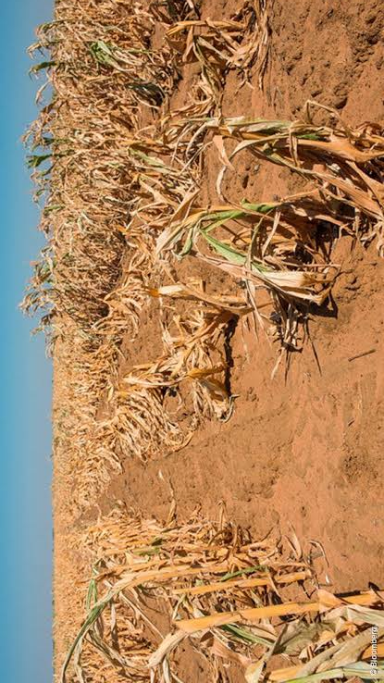
- Water sources reduced to muddy pools; families queueing at scarce wells.
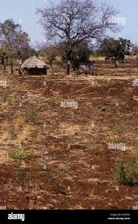

Flooding and Displacement:
Recent severe flooding in central Nigeria in late May 2025 caused over 150 deaths and displaced thousands, while a 2022 flood event also in Nigeria resulted in hundreds of deaths and over 1.3 million displaced people due to widespread extreme weather across the region.
These incidents highlight a pattern of recurrent, devastating floods in West and Central Africa, linked to both climatic factors like extreme rainfall and factors like dam overflow and poor infrastructure, with the UNHCR emphasizing the growing humanitarian crisis caused by such events.
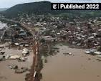
- Photos of flooded communities in West Africa and northern Nigeria where hundreds died and millions were displaced.
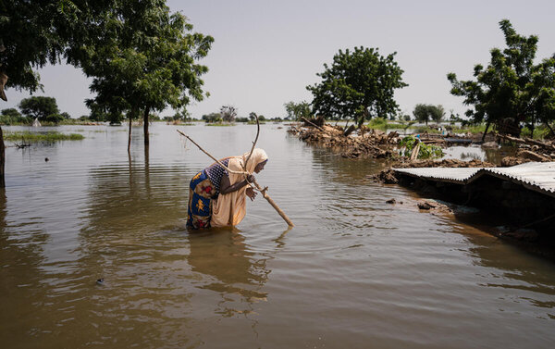
- Children and elderly wading through water, makeshift shelters, ruined infrastructure.
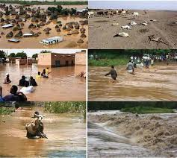

Impact on Rural and Urban Communities:
Rural farmers whose livelihoods are devastated.
- Rural farmers in Mathari are vulnerable to economic hardship when their livelihoods are devastated by factors such as lack of access to credit and technology, high input costs, environmental shocks like floods and landslides, and conflict-driven disruptions to supply chains and land access, all of which can lead to food insecurity and a drastic decline in income. Below is an image:
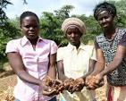
In some rural areas in Tanzania the land has also experienced degradation which is shown in the image below
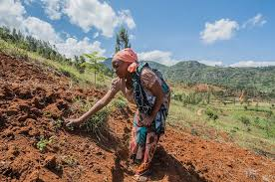
Urban slums and informal settlements vulnerable to rains and heatwaves.
- Urban slums and informal settlements are highly vulnerable to rains and heatwaves due to factors like poor housing, lack of essential infrastructure, inadequate urban planning, and precarious locations in ecologically sensitive areas. Climate change exacerbates these issues, increasing the risk of flooding, landslides, and extreme heat, which disproportionately affects residents and widens existing inequalities. Addressing this vulnerability requires comprehensive, inclusive, and community-focused climate adaptation and mitigation efforts that go beyond hazard management to tackle the root causes of risk, such as poverty and weak governance.
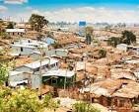
Food Insecurity and Its Effects:
Families faced with acute food shortages due to failed harvests and market disruption.
- Families experiencing acute food shortages from failed harvests and market disruption are in a state of food insecurity, a situation often exacerbated by factors like climate shocks, conflict, economic downturns, and logistical challenges. Addressing this requires interventions such as food distributions, commodity vouchers, restoring market access, improving food availability, and implementing long-term solutions to build resilience to future shocks.
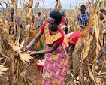
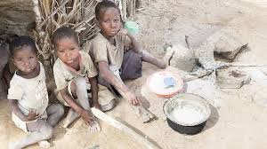
Visuals of aid distribution, empty marketplaces, and children affected by malnutrition. An image taken in Burkina Faso.
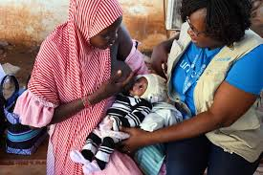
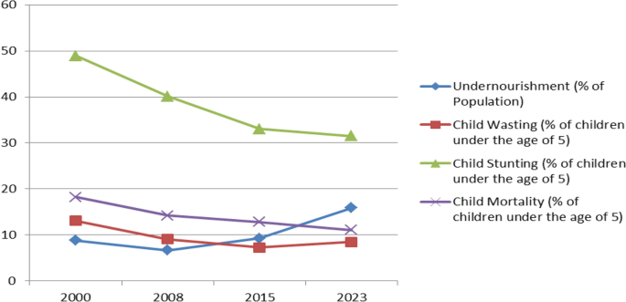
A visual of malnutrition and food insecurity in northern Nigeria
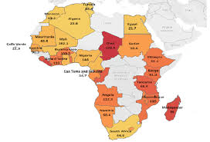
Mapping of malnutrition in Africa.

Loss of Biodiversity and Natural Habitats:
Loss of biodiversity and natural habitats is the decline in the variety of life on Earth and the destruction of ecosystems like forests and wetlands, primarily driven by human activities such as land use for agriculture, overexploitation of species, pollution, and climate change.
This loss threatens essential ecosystem services, harms human health, and can lead to species extinction. Efforts to address this crisis involve reforming food systems, restoring degraded lands, and implementing more nature-friendly farming practices.
Images showing deforestation, dried riverbeds, and wildlife threatened by habitat loss.
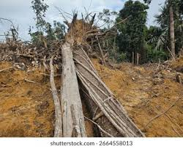
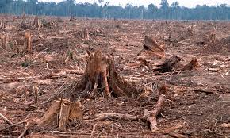
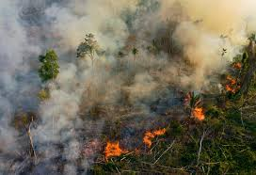
Resilience and Solutions:
Resilience and Solutions refers to strategies, actions, and services designed to help organizations and communities withstand, adapt to, and recover from disruptions, such as climate change impacts, natural disasters, or cyberattacks. These solutions can involve risk assessments, strategic planning, technical support, capacity building, policy strengthening, and the development of IT tools and infrastructure, often implemented by specialized consulting firms and government agencies.
- Portraits of community-led adaptation: rainwater harvesting projects, environmental clubs, and wildlife rescue initiatives like DAKTARI Bush School & Wildlife Orphanage.
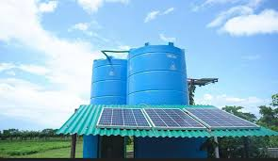
An example of water harvesting project that has been adopted as a solution to the problems faced in African communities
- Local leaders and environmental activists in action. An example is Kajiado county government which has taken bold actions in solving the drought they have been experiencing. These initiatives have marked a step to reclaiming back their lands through solving the weed problem which has been a devastating problem to their crops, animals and their lands in general.
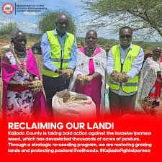
Global Context and Calls for Action:
Infographics showing Africa’s climate finance gap, international pledges from forums such as COP29, and how funding still falls short of real needs.
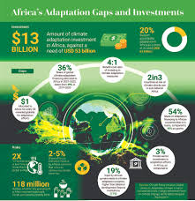
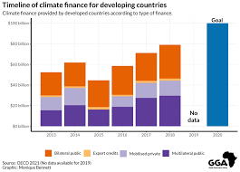
IN CONCLUSION:
The imperative for sustainable development, policy engagement, and community resilience as shown through everyday African lives.
The climate and environmental crisis significantly threatens Africa's stability and development, causing increased natural disasters, food and water insecurity, and displacement. These impacts are disproportionately felt by vulnerable communities, undermining decades of progress and potentially worsening social tensions and inequalities.
Addressing this crisis requires immediate, localized adaptation and mitigation strategies, stronger institutional capacity, and tailored policies that foster climate resilience and justice across the diverse African continent.

